Day 1 Lab Assignments

1. Design the following sample home page using the following main layout for Desktop (and make sure that it’s completely responsive):
2. You can use your old home page layout (In JS labs) instead of the following image if you like)
3. Pay more attention for layout, not for the content.
4. Make your page fully responsive (use viewport meta tag).
5. DON’T use tables in you layout, use divs & spans (or new HTML5 structural elements), with CSS instead.
6. Use flexbox instead of floating.
7. Try flex wrap properties, to make sure that the columns will appear below each other in the small size.
8. Make your images, Videos responsive.
9. Don’t use media queries, use the default action of flex box (The left bar its size will only decrease on its place).

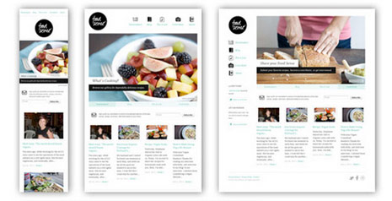

1. Use grid layout with your CV page design, and make sure that it’s completely responsive (use viewport meta tag):
   1. Change the middle content in the given image to be full-page width.
   2. Use 16 columns layout.
   3. Set box-sizing property.
   4. Use Viewport units with the font size for text in the header (Name), and max-width with the image.
   5. Use float property or flexbox.
   6. Use **flex** instead of float (**Bonus**).
   7. What are the differences between custom grid layout, and CSS display: grid?
      1. Use CSS grid, instead of Custom grid (<https://www.w3schools.com/css/css_grid.asp>).
   8. Change the header image in tablet and mobile view (Use picture tag).

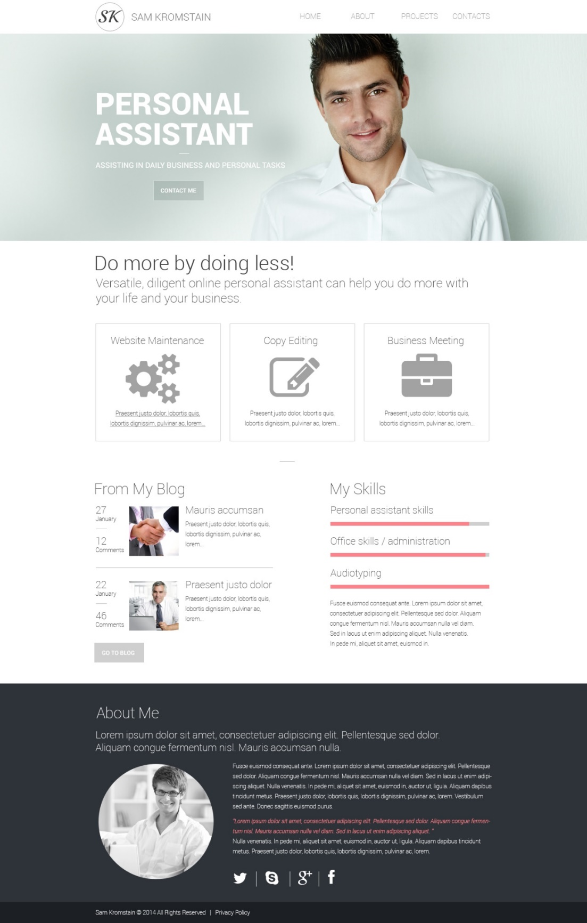

**Bonus Assignment:**

1. What are the differences between custom grid layout, and CSS display: grid?

<https://www.w3schools.com/css/css_grid.asp>